Birthday Guessing Game

Hissamuddin Shaikh

CSCI 201

22nd May 2018

St. Cloud State University

**Birthday Guessing Game**

**Problem Statement**:

Determine the birthdate of the user, based on their response to five different sets of monthly dates, through the binary value of the number (day of month).

**Input/Output Description:**

Input: The users response in “Yes” or “No” to the Set being displayed, with regards to whether the Set presented, contains their birthdate or not. (This occurs 5 times, as there are 5 sets of monthly dates.)

Output: The birthdate of the user (within a statement).

**Variables:**

* *A, B, C, D & E*
  + Each one of the variables (letters) stores the title for each set, such as “Set 1”, “Set 2” and so on….
  + Type: String
* *a, b, c, d & e*
  + Each one of the variables (letters) stores the “Yes” or “No” response that the user has to the particular set being displayed.
  + Type: String
* *a_result, b_result, c_result, d_result & e_result*
  + Each one of the variable stores the Boolean result of the user’s response to a particular set, by converting a “Yes” to a 1/true, and a “No” to a 0/false through an if statement.
  + Type: Boolean
* *end_result*
  + Stores the predicted birthdate, which has been calculated, based on the Boolean version of the user’s responses to all the sets.
  + Type: Integer

**Program Design:**

1. Display a set of numbers that all have “1” in the right most digit of their Binary value and exclude those that have “0” for that digit.
2. Prompt the user to respond “Yes” or “No”, if their birthdate is present in the displayed set.
3. Set up an if statement that converts a “Yes” response to “true”, and a “No” response to a “false” in Boolean. This will result in a 1(true) and a 0 (false) and allow us to calculate the birthdate.
4. Repeat steps 1 to 3 with four different sets, with the difference being in the numbers present in the sets. With each subsequent set, move one digit to the left and collect the numbers that have “1” in that spot for their Binary values, and exclude the numbers that have “0” in that spot. (In total, you should receive 5 responses from the user, as a Binary value for a number has 5 digits).
5. Using the 5 responses, calculate the birthdate by multiplying each response with its respective power with a base of 2 (starting at the power of 0 (2^0) for the response to the right most digit, all the way up till the power of 4 (4^0), for the leftmost digit). Add all the 5 results that you get after the multiplication and display the result as that is their birthdate.

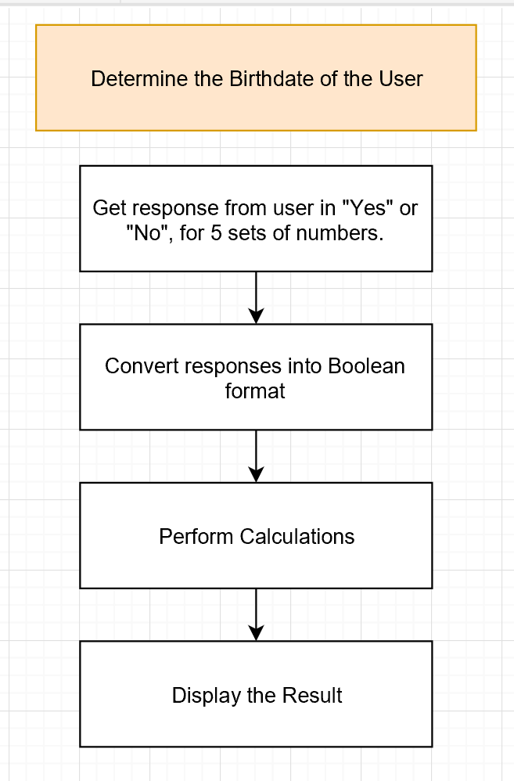**Flowchart:**

Figure. A

Note: “Convert responses into Boolean format” and “Perform Calculations” are further explained below in Figure. B and Figure. C.

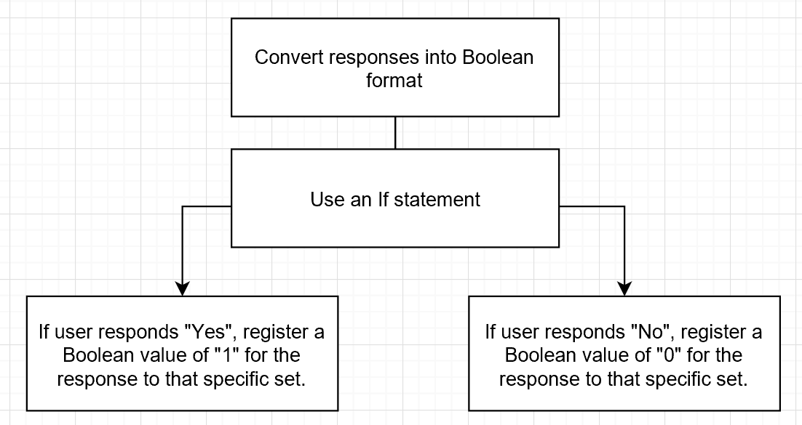

Figure. B

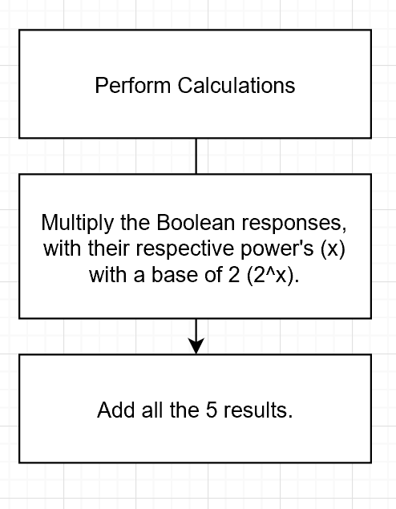

Figure. C

**Algorithm Development (Detailed Pseudocode):**

* Display “Set 1” through *A*, above a list of all the numbers that fall within that set.
* Prompt user to input “Yes” or “No” with the statement; “Does your Birthday appear in this set?”. Store the response in *a*.
* if (*a*=="Yes"||*a*=="yes"||*a*=="YES"||*a*=="YEs"||*a*=="yES"||*a*=="yEs"||*a*=="yeS")

*a_result* = true;

* Repeat this for the remaining 4 sets, changing all alphabets subsequently from *B* to *E*, *b* to *e* and *b_result* to *e_result*.
* *end_result* = (*a_result*\*1) + (*b_result*\*2) + (*c_result*\*4) + (*d_result*\*8) + (*e_result*\*16)
* Display *end_result*, within the statement, “Your Birthday is on the (*end_result*) of your respective month.”

**Program Listing:**

1. /*Birthday Guessing Game by Hissamuddin Shaikh*/
2. /*If copying to run program, care to remove all numbered bullet points before copying*/
3. #include <iostream>
4. #include <iomanip>
5. #include <cmath>
6. #include <string>
7. using namespace std;
8. int main()
9. { /* Initialization of variables*/
10. string A = "Set 1"; string a; bool a_result = false; int end_result;
11. string B = "Set 2"; string b; bool b_result = false;
12. string C = "Set 3"; string c; bool c_result = false;
13. string D = "Set 4"; string d; bool d_result = false;
14. string E = "Set 5"; string e; bool e_result = false;
15. /* Setup for displaying Set 1 */
16. cout << setw(15)<< A << endl << " ------------------------" << endl <<
17. setw(3) << "1" << setw(3) << "3" << setw(3) << "5" << setw(3)<< "7" << setw(3) << "9" <<
18. setw(3)<< "11" << setw(3) << "13" << setw(3) << "15" << endl;
19. cout << setw(3) << "17" << setw(3)<< "19" << setw(3) << "21" << setw(3) << "23" << setw(3) << "25" <<
20. setw(3) << "27" << setw(3) << "29" << setw(3) << "31" <<endl;
21. /* Setup for getting response to Set 1 */
22. cout << endl << " Does your Birthday appear in this set? (Answer Yes or No) ";
23. cin >> a;
24. /*Setup for checking what they entered and initialization for the final output*/
25. if (a=="Yes"||a=="yes"||a=="YES"||a=="YEs"||a=="yES"||a=="yEs"||a=="yeS")
26. a_result = true;
27. /* Setup for displaying Set 2 */
28. cout << endl <<setw(15)<< B << endl << " ------------------------" << endl <<
29. setw(3) << "2" << setw(3) << "3" << setw(3) << "6" << setw(3)<< "7" << setw(3) << "10" <<
30. setw(3)<< "11" << setw(3) << "14" << setw(3) << "15" << endl;
31. cout << setw(3) << "18" << setw(3)<< "19" << setw(3) << "22" << setw(3) << "23" << setw(3) << "26" <<
32. setw(3) << "27" << setw(3) << "30" << setw(3) << "31" <<endl;
33. /* Setup for getting response to Set 2 */
34. cout << endl << " Does your Birthday appear in this set? (Answer Yes or No) ";
35. cin >> b;
36. /*Setup for checking what they entered and initialization for the final output*/
37. if (b=="Yes"||b=="yes"||b=="YES"||b=="YEs"||b=="yES"||b=="yEs"||b=="yeS")
38. b_result = true;
39. /* Setup for displaying Set 3 */
40. cout << endl<< setw(15)<< C << endl << " ------------------------" << endl <<
41. setw(3) << "4" << setw(3) << "5" << setw(3) << "6" << setw(3)<< "7" << setw(3) << "12" <<
42. setw(3)<< "13" << setw(3) << "14" << setw(3) << "15" << endl;
43. cout << setw(3) << "20" << setw(3)<< "21" << setw(3) << "22" << setw(3) << "23" << setw(3) << "28" <<
44. setw(3) << "29" << setw(3) << "30" << setw(3) << "31" <<endl;
45. /* Setup for getting response to Set 1 */
46. cout << endl << " Does your Birthday appear in this set? (Answer Yes or No) ";
47. cin >> c;
48. /*Setup for checking what they entered and initialization for the final output*/
49. if (c=="Yes"||c=="yes"||c=="YES"||c=="YEs"||c=="yES"||c=="yEs"||c=="yeS")
50. c_result = true;
51. /* Setup for displaying Set 1 */
52. cout << endl <<setw(15)<< D << endl << " ------------------------" << endl <<
53. setw(3) << "8" << setw(3) << "9" << setw(3) << "10" << setw(3)<< "11" << setw(3) << "12" <<
54. setw(3)<< "13" << setw(3) << "14" << setw(3) << "15" << endl;
55. cout << setw(3) << "24" << setw(3)<< "25" << setw(3) << "26" << setw(3) << "27" << setw(3) << "28" <<
56. setw(3) << "29" << setw(3) << "30" << setw(3) << "31" <<endl;
57. /* Setup for getting response to Set 1 */
58. cout << endl << " Does your Birthday appear in this set? (Answer Yes or No) ";
59. cin >> d;
60. /*Setup for checking what they entered and initialization for the final output*/
61. if (d=="Yes"||d=="yes"||d=="YES"||d=="YEs"||d=="yES"||d=="yEs"||d=="yeS")
62. d_result = true;
63. /* Setup for displaying Set 1 */
64. cout << endl <<setw(15)<< E << endl << " ------------------------" << endl <<
65. setw(3) << "16" << setw(3) << "17" << setw(3) << "18" << setw(3)<< "19" << setw(3) << "20" <<
66. setw(3)<< "21" << setw(3) << "22" << setw(3) << "23" << endl;
67. cout << setw(3) << "24" << setw(3)<< "25" << setw(3) << "26" << setw(3) << "27" << setw(3) << "28" <<
68. setw(3) << "29" << setw(3) << "30" << setw(3) << "31" <<endl;
69. /* Setup for getting response to Set 1 */
70. cout << endl << " Does your Birthday appear in this set? (Answer Yes or No) ";
71. cin >> e;
72. /*Setup for checking what they entered and initialization for the final output*/
73. if (e=="Yes"||e=="yes"||e=="YES"||e=="YEs"||e=="yES"||e=="yEs"||e=="yeS")
74. e_result = true;
75. /*Calculating and displaying the Final Output*/
76. end_result = (a_result*1)+(b_result*2)+(c_result*4)+(d_result*8)+(e_result*16);
77. cout << endl << endl << " Your Birthday is on the " << end_result <<" of your respective month."<< endl << endl;
78. return 0;
79. }

**Note:**

Screenshots of the original code are attached at the end of the document if this is unclear.

**Sample test run of the program:**

1st Sample:

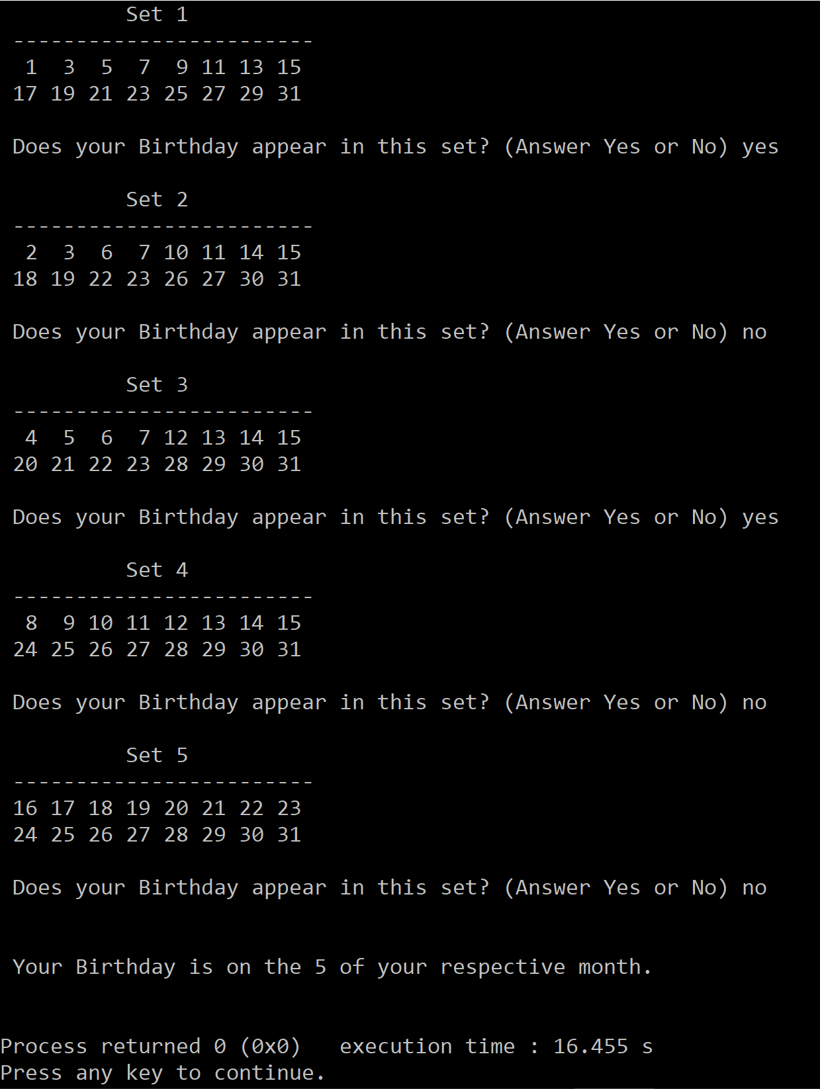

2nd Sample:

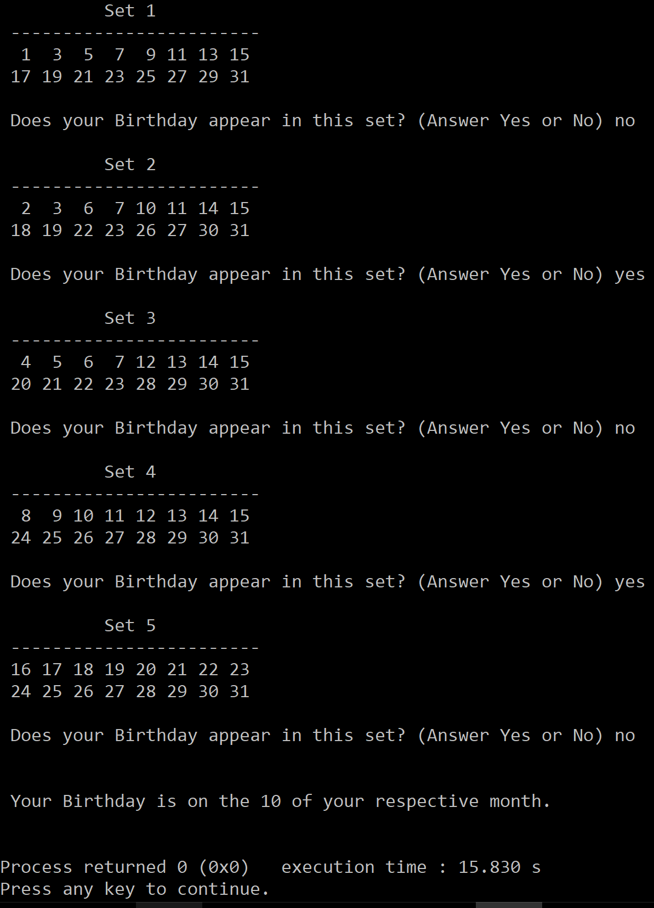

**Observations, error handling and general comments:**

The program runs correctly as the result in the 1st example and the 2nd example correspond to manual computations.

**1st example (Manual Computation) =**

User Birthdate: 5

Predicted Birthdate: Responses – “Yes”, “No”, “Yes”, “No”, “No”

Boolean Translation: 1, 0, 1, 0, 0

Co-responding Number: (1*1) + (0*2) + (1*4) + (0*8) + (0*16) = 5

Result: 5

This is the same as the one computed by the computer and is correct with regards to Boolean translation as 5 is in fact, 10100 in Binary.

**2nd example (Manual Computation) =**

User Birthdate: 10

Predicted Birthdate: Responses – “No”, “Yes”, “No”, “Yes”, “No”

Boolean Translation: 0, 1, 0, 1, 0

Co-responding Number: (0*1) + (1*2) + (0*4) + (1*8) + (0*16) = 10

Result: 10

This is the same as the one computed by the computer and is correct with regards to Boolean translation as 5 is in fact, 01010 in Binary.

No errors should be encountered at all, as long as the user enter yes or no. The format of their input (such as caps) doesn’t matter as the if statement is setup to register the word” Yes” in all formats, and the input of the word “No” would automatically register the desired result as the Boolean variables have been initialized as “false” or 0, so the format of “No”, doesn’t matter either. However, an error in result could result if the user misspells when inputting “Yes”, as that would not change the initial false value of the Boolean variable, since the if statement to change that will only work if the word “Yes” is spelled correctly.

**Conclusions**

The Birthday Guessing Game that has been constructed in this report should serve sufficiently and efficiently, with regards to predicting the birthday of the user. There is minimal room for error, as the only way this can go wrong is if the user misspells the word yes, when typing it in. Moreover, the material is presented very neatly, and the prompts and description are very clear for the user to follow along as intended by the program.

A screenshot of a social media post

Description generated with very high confidenceNotes:

A screenshot of a social media post

Description generated with very high confidence

A screenshot of a computer

Description generated with very high confidence